# Comp 2322 Computer Networking

**Lab 2: HTTP**

**Student Name: HE YIYANG**

**Student ID:22100143D**

Q2.

Accept-Language: zh-CN,zh;q=0.9

Q4.

Status Code: 200

Q6.

Content-Length: 128

Screen shot for Q2,4,6

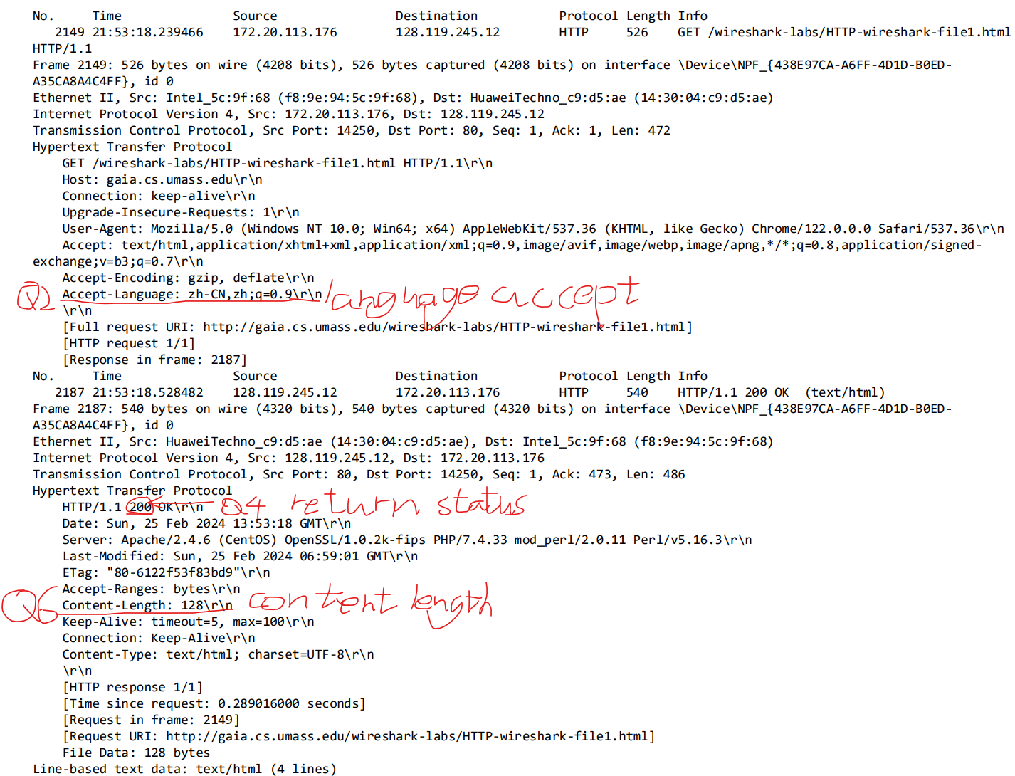

Q8.

No: there is no “IF-MODIFIED-SINCE” here

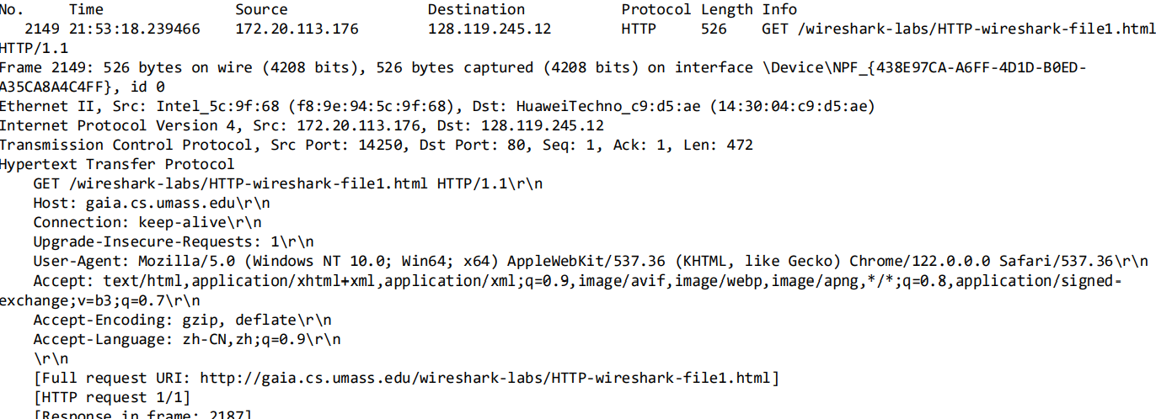

Q10.

Yes If-Modified-Since: Sun, 25 Feb 2024 06:59:01 GMT

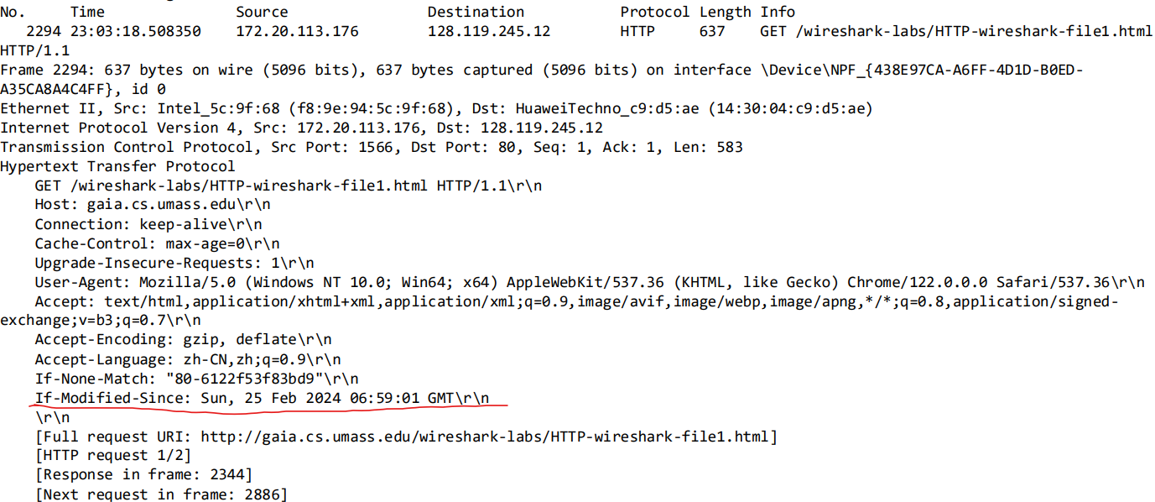

Q12.

1 HTTP GET request message.

Package number in the trace contains the GET message for the Bill of Rights: 2026



Q14.

Status Code: 200

Response Phrase: OK

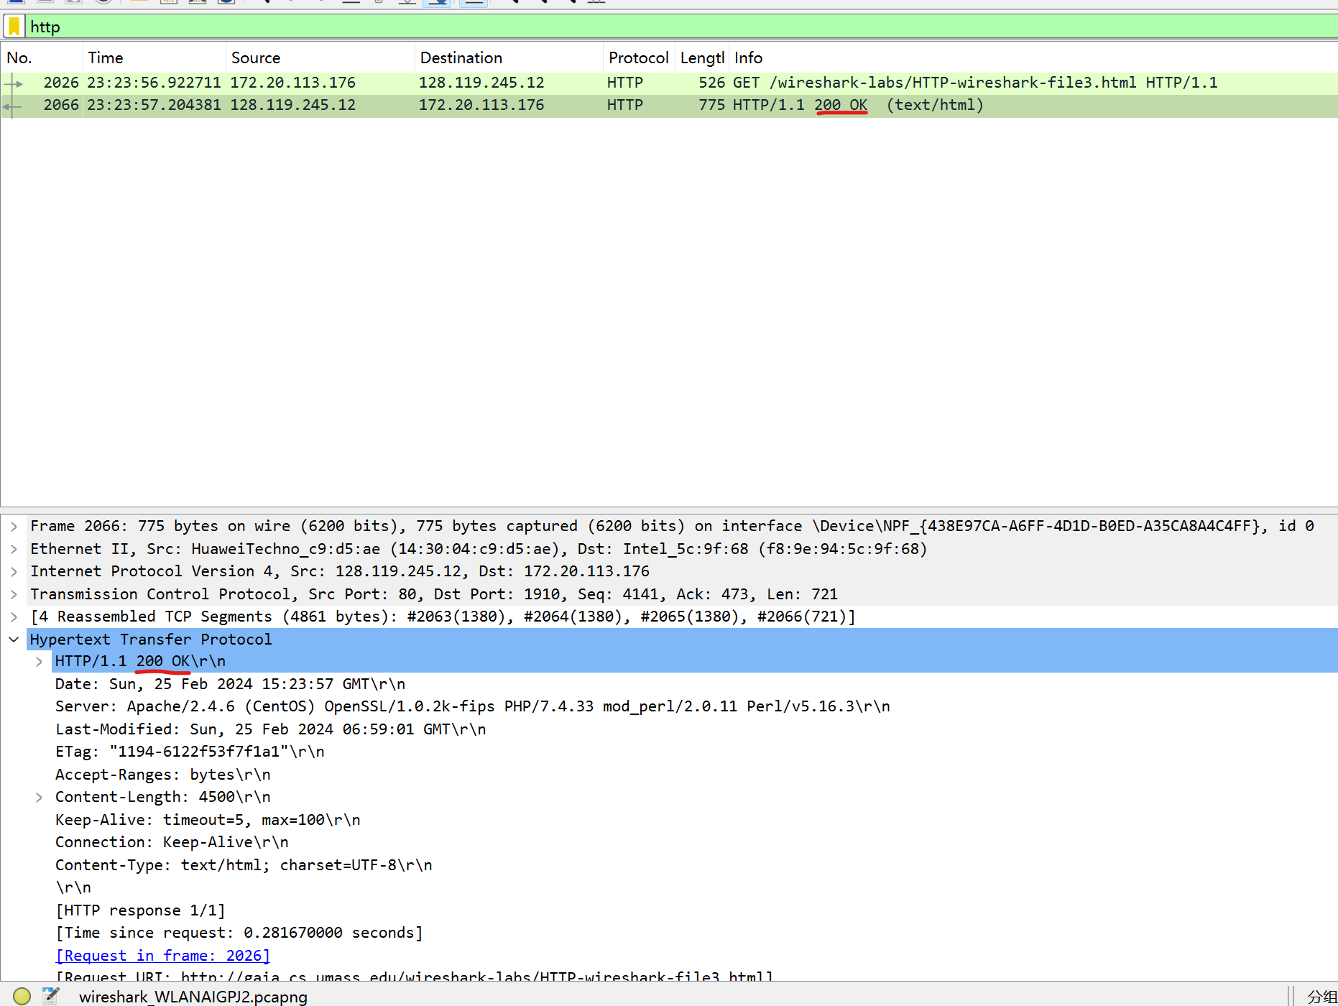

Q16.

3 HTTP GET messages sent: package 759, package 827, package 949.

Package 759 sent to 128.119.245.12

Package 827 sent to 128.119.245.12

Package 949 sent to 178.79.137.164

